
Coal Project Report

Title: Palindrome Detector in 8086 Assembly

Submitted By:
Abdul Rafay (Roll No: 243705)
Abdullah Rafay (Roll No: 243619)

Course & Instructor:
Subject Instructor: Eng. Anum Aftab
Course: Computer Organization & Assembly Language (COAL)

Institution Details:
Air University, Multan Campus
Spring 2025

1. Abstract
This project presents the design and implementation of a fully functional Palindrome Checker using 8086 Assembly Language. The primary objective was to create a robust string manipulation utility that showcases advanced pointer and loop logic within low-level programming constraints. Unlike basic checkers, this system features dynamic string length support, case-insensitivity, and input sanitization (ignoring spaces and punctuation). The project demonstrates proficiency in memory segmentation, register management (SI, DI, CX), and modular programming.

2. Introduction & Objectives
A palindrome is a sequence of characters that reads the same forward and backward (e.g., "MADAM" or "racecar"). While high-level languages offer built-in string reversal functions, implementing this in Assembly requires manual manipulation of memory and CPU registers.
Primary Objectives:
- To implement a fully functional checker in EMU8086.
- To accept user input strings of dynamic length.
- To manually implement string reversal and comparison algorithms.
Innovations:
This project improves upon standard implementations by adding:
- Case-Insensitivity: Converts all input to uppercase before comparison to ensure "Madam" matches "madam".
- Sanitization: Ignores special characters and spaces, enabling sentence-level checking (e.g., "A man, a plan...").
- Robust Error Handling: Detects empty inputs and provides clear feedback.

3. Concepts Used & Theoretical Framework
To achieve the objectives above, the following core COAL concepts and 8086 architectural features were utilized:
- Modular Programming (Procedures): The code is structured into subroutines (TO_UPPER_CASE, SANITIZE_INPUT, REVERSE_STRING) using PROC and ENDP directives. This ensures code reusability and simplifies debugging.
- Macros: A PRINT_STR macro was defined to handle repetitive I/O tasks efficiently, reducing code redundancy.
- String Instructions & The Extra Segment (ES): The logic heavily relies on the REPE CMPSB (Repeat Compare String Byte) instruction. To support this, the Extra Segment (ES) was manually initialized to match the Data Segment (DS), ensuring accurate memory comparisons.
- Indexed Addressing (SI/DI): The Source Index (SI) and Destination Index (DI) registers were used as pointers to traverse input buffers and generate the reversed string in memory.
- Stack Operations: Context preservation was achieved using PUSH and POP instructions to save register states before procedure calls, preventing data corruption.
- ASCII Arithmetic: Case conversion was implemented by manipulating ASCII values (subtracting 32 from lowercase letters).

4. System Flow & Methodology
The program follows a modular design to handle input, processing, and output distinctively.
4.1 Flowchart Overview
The system initializes the data segment and enters a continuous loop. It accepts input, validates it, sanitizes the string, reverses it, and performs a byte-by-byte comparison.
4.2 Functional Modules
The solution is divided into the following procedures:
- TO_UPPER_CASE: Iterates through the raw input buffer and converts characters 'a'-'z' to uppercase using ASCII arithmetic.
- SANITIZE_INPUT: This filters the input string, moving only alphanumeric characters to a clean buffer. Punctuation and spaces are discarded.
- REVERSE_STRING: Uses SI and DI pointers to read from the end of the clean string and write to the beginning of the REVERSED_STR buffer.
- COMPARE_BUFFERS: Uses the REPE CMPSB instruction to compare the sanitized string with the reversed string. If a mismatch is found, the Zero Flag (ZF) is cleared.

5. Implementation Details
The project deals with several low-level challenges identified in the proposal:
- Memory Management: We utilized the ES register to ensure string comparison instructions functioned correctly across memory segments.
- Dynamic Input: The system uses interrupt 21H (Service 0AH) to capture buffered input, allowing for variable lengths up to 80 characters.
- Logic Control: The program flow is controlled via JMP and LOOP instructions, ensuring the user can continuously check strings until they type "EXIT".

6. System Output & Screenshots
In this section, valid operational screenshots are provided to demonstrate the functionality.
6.1 Full Program Interface
This screenshot displays the complete program execution window, including the project banner, the "Palindrome Checker" title, and the initial user prompt.
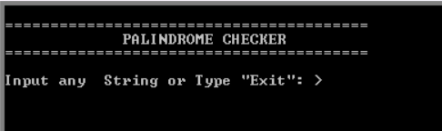
Caption: Overview of the program interface running in the EMU8086 console.
6.2 Simple Palindrome Test
Input: "LEVEL"
Result: Detected as Palindrome.
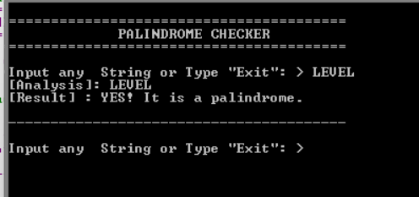
Caption: The system correctly identifies a simple, same-case palindrome.

6.3 Case-Insensitive Test (Innovation)
Input: "Madam"
Result: Detected as Palindrome (Internal logic converts to "MADAM").
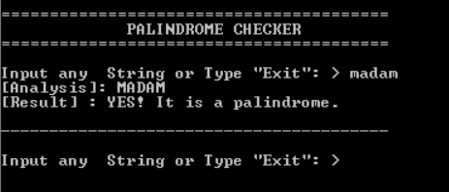
Caption: Demonstration of case-insensitivity features.
6.4 Complex Sentence Test (Sanitization)
Input: "Madam, I'm Adam"
Result: Detected as Palindrome.
Explanation: The sanitizer reduces this to "MADAMIMADAM" before checking.
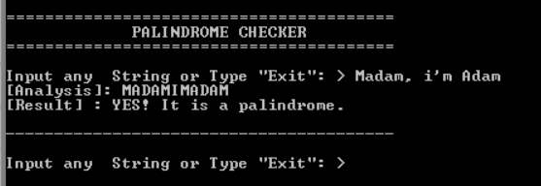
Caption: The system ignoring punctuation and spaces.
6.5 Non-Palindrome & Error Handling
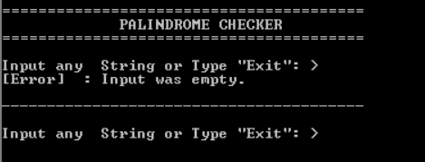
Input: "Hello" / [Empty Input]
Result: "Not a Palindrome" / "Input was empty."
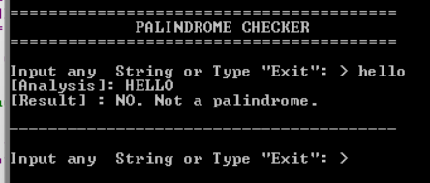
Caption: Handling of negative results and input validation errors.

7. Testing Strategy & Results
We conducted rigorous testing based on the edge cases defined in our proposal.
Test Case | Input Data | Expected Output | Actual Result | Status
Even-Length | "noon" | Palindrome | Palindrome | Pass
Odd-Length | "kayak" | Palindrome | Palindrome | Pass
Mixed Case | "Racecar" | Palindrome | Palindrome | Pass
Numeric | "12321" | Palindrome | Palindrome | Pass
Sentence | "No x in Nixon" | Palindrome | Palindrome | Pass
Non-Palindrome | "Assembly" | Not Palindrome | Not Palindrome | Pass
Exit Command | "EXIT" | Terminate Program | Terminate Program | Pass

8. Conclusion
This project successfully met all objectives outlined in the proposal. By implementing manual memory pointers (SI/DI) and ASCII arithmetic for case conversion, we demonstrated a deep understanding of the 8086 architectures. The addition of input sanitization makes this tool significantly more practical than standard textbook examples, fulfilling the goal of creating a "robust string manipulation utility".

